聖光聖經學院簡介 戴紹曾 院長
自六十年前循理會在中國開始宣教工作的時候，就非常重視教導青年人研究神的話，以發展中國教會並將福音傳自未曾聽見的地方。一九五五年在永冕牧師在台灣創立的聖光聖經學院，是大陸上開封聖經學院與西北聖經學院之延續。從後者曾產生有名的遍傳福音團，神差派許多中國宣教士遠往新疆並靠近阿富汗邊界的喀什米爾傳揚福音。
聖光聖經學院初創時只有十八位學生，現已逐漸增加到五十位之多，其中女生約占三分之一。學生籍貫大陸與本省各半。高雄附近教會信徒常有申請旁聽者。香港、韓國最近亦有申請入學之青年。聖光按學制分為兩科：及四年制的神學科招收高中畢業生，三年至的聖經科招收初中畢業生。一切課程均以聖經為中心。日下已畢業學生七屆共六十四位，分布全台灣。大多數在牧養教會，亦有從事基督教文字與教育工作、福音廣播、及軍中傳道者。
一九五五年初創時之簡陋校舍，至翌年開學時即已不足容納日益增多的學生因此不得不在校外租屋做為男生宿舍。一九五八年，神垂聽禱告，使聖光能買到校址對面不遠日式二層樓房一棟。嗣後於一九六三年又買下隔鄰的房屋作為院長宿舍。最後，神藉著美國和台灣信徒的甘心奉獻，使我們能建造這座美奐美崙嶄新完備的聖光大樓，以替換我們已使用了十年的簡陋校舍。

摘錄自「聖光聖經學院新廈落成紀念特刊」1965年5月5日 頁2

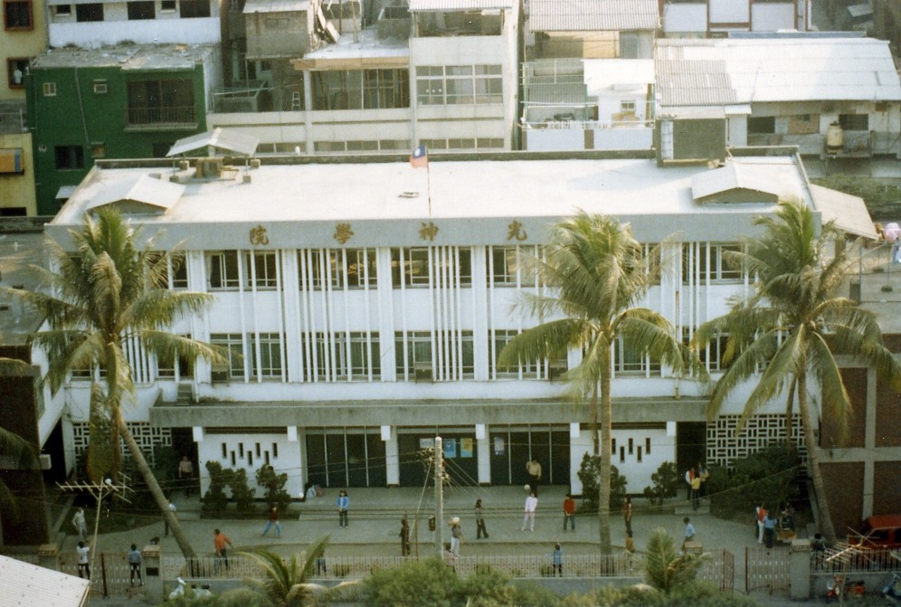

Introducing Holy Light Bible Seminary James H. Taylor, Jr.

From the beginning of its missionary endeavor in China sixty years ago, the Free Methodist Church has given serious attention to instructing young people in the Word of God, in order to promote the development of the Chinese Church and the preaching of the Gospel in unreached areas. Holy Light Bible Seminary, established in Taiwan in 1955 by James H. Taylor, Sr. thus continues in the line of the Kaifeng Bible School and the Northwest Bible Institute, from which originated the remarkable, indigenous Back to Jerusalem Evangelistic Band which sent Chinese missionaries from the Northwest Bible Institute to Hsinkiang and the borders of Kashmir.
The student body of our seminary which numbered eighteen the opening year, has steadily increased to the present enrolment of fifty. It includes both men and women, who are about evenly divided between students from the Mainland and those from Taiwan.

From: “Holy Light Bible Seminary Dedication Feature Kaohsiung, Taiwan, May 5, 1965” p.2

